Tableau Mini Project

## Problem Statement:

Create Interactive Dashboards shown using the *cities* dataset that is provided.

## Expected Functions:

### Dashboard 1:

* Enable Filter on Statewise Population - by selecting any of the States on the map, the Genderwise Population has to show only the selected States’ Male and Female population numbers.
* Similarly, selecting the Name of State on the Genderwise State Population the map of the selected State needs to be displayed.
* Observe the Y-axis labels have been changed to make it more readable in Genderwise State Population plot

### Dashboard 2:

* The Genderwise Literacy Plot should show the Proportion of Male/Female population that are literate
  + **Hint:** You need to create 2 Calculated Fields
    - Female Literacy Proportion = (Literates Female) / (Population Female)
    - Male Literacy Proportion = (Literates Male) / (Population Male)
  + Enable Filter on Genderwise Literacy Plot – By selecting the State, Cities from the selected State (if any) in the Bottom 10 Male/Female Literacy Proportion need to be displayed
* Comment on the insight you are able to get from the Genderwise Literacy plot
* The two Calculated Fields (Female Literacy Proportion and Male Literacy Proportion) will be used in the other two plots. **We are trying to find the Cities that have the lowest proportions of Male and Female Literate Population**.
  + **Hint:** You will be using the Filter Pane for find the Lowest 10 Cities

Expected Deliverables:

* Create the 2 Dashboards and save it on Tableau Public
* Post the Tableau Public link where you have your work on LMS assignment section
* Dashboard 2 requires you to comment on the insight gained from the Genderwise Literacy Plot – Expect at least 3 observations.

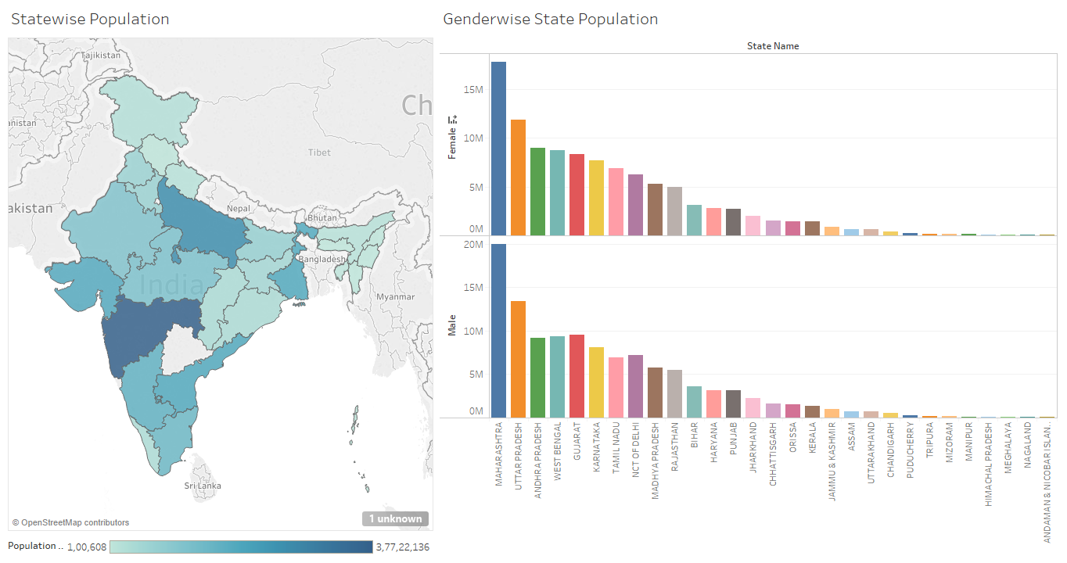

Dashboard 1

Dashboard 2

